DEF095280 BAFL System Sounds Design Changes

Security Classification: | Confidential
Document Reference: | SGL.TS0017.322
Status: | Issued
Version: | 1.0
Team/Department : | System Libraries / Software Engineering
Technology Stream: | Base Services
Owner(s): | George Sewell
Approver(s): | Stephen Mansfield
Distribution: | Internal

Contents
1 Introduction 3
1.1 Purpose and Scope 3
2 Design Overview 4
2.1 Class Diagram 4
2.1.1 TBaSystemSoundType 6
2.1.2 TBaSystemSoundUid 6
2.1.3 TBaSystemSoundInfo 6
2.1.4 TBaSoundPriorityEncoder 6
2.1.5 TBaSoundPriorityDecoder 6
2.1.6 BaSystemSound 6
2.1.7 CBaSystemSoundArray 6
2.1.8 CBaSsndStore 6
2.2 Classes Undergoing Changes 7
2.2.1 BaSystemSound 7
2.2.2 CBaSystemSoundArray 7
2.2.3 TBaSystemSoundInfo 8
2.2.4 CBaSsndStore 8
3 DEF095280 Detailed Design 9
3.1 TBaSystemSoundInfo CentRep Data Schema 9
3.2 CBaSsndStore Implementation 9
3.2.1 GetSound Interaction 10
3.2.2 SetSoundL Interaction 10
3.2.3 CBaSystemSoundArray::RestoreL Interaction 11
3.3 CentRep and Backup Registration Files 12
4 Testing 13
4.1 Performance Tests 13
4.2 Component and Unit Tests 13
4.3 Robustness Testing 13
4.3.1 CentRep server locked out 13
4.3.2 CentRep server start fail 13
4.3.3 Data corruption at repository level 13
4.3.4 Data corruption at settings level 13
4.3.5 Rogue entries in repository 14
4.4 Regress Tests 14
5 Further Information 14
5.1 References 14
5.2 Open Issues 15
5.3 People 15
5.4 Document History 15
Appendix A - CentRep initialization file for System Sound 16
Appendix B - Backup registration file 17

Introduction

Purpose and Scope
This document describes the implementation details of DEF095280 - System Sounds are vulnerable to attack from malicious software. There are two security issues with the current BAFL System Sound APIs:
- No restriction on write access to system sound settings. A rogue application can freely modify the settings.
- Settings are stored in a public file. A rogue application can freely corrupt the file.
The proposed solution of DEF095280 is to store the system sound settings in Central Repository (CentRep) and impose a write policy so that only processes with WriteDeviceData capability can modify the settings.
Target audience of this document are:
- Technical architects – for reviewing.
- Software Engineers developing features on BAFL System Sounds – for reviewing.
- Defect fixers – to get background information about the implementation.
- Verification Engineers – to design tests for BAFL System Sound APIs.

Design Overview
This section provides an overview of the C++ classes of BAFL System Sound.

Class Diagram
The static view of BAFL System Sound is shown in Figure 1 Components of BAFL System Sound.

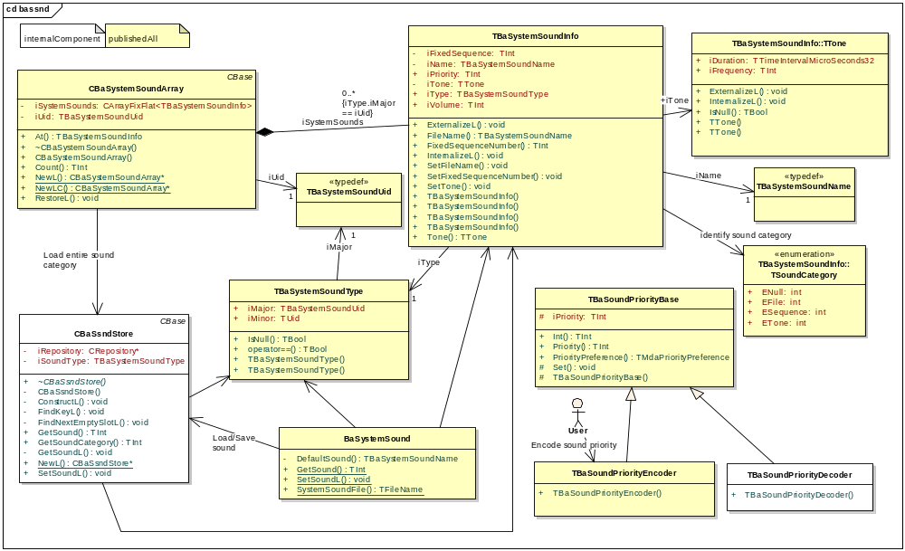
Figure 1 Components of BAFL System Sound
The CBaSsndStore class is a new class introduced by DEF095280 fix. All the other classes are common to both the new and current implementations. The following sections briefly describe the purpose of each class.

TBaSystemSoundType
This type uniquely identifies a system sound. TBaSystemSoundType is made up of two components:
- TBaSystemSoundUid is a TUid which specifies a sound category.
- Minor UID is a TUid which specifies an instance within a sound category.

TBaSystemSoundUid
This is a component of TBaSystemSoundType. It specifies a sound category.

TBaSystemSoundInfo
This struct encapsulates the detail information of a system sound such as the sound ID, priority, volume, sound file name, etc. It has the following subclasses:
- TTone. A Sound may be a tone, a fixed sequence or a file. This class provides the functions to define a tone based sound.
- TBaSystemSoundName. This is typedef of TFileName. It is for holding the filename of a file based sound.
- TSoundCategory. This is an enum to specify whether the sound is a tone, a fixed sequence or a file.

TBaSoundPriorityEncoder
The users use this class to encode three sub-fields of sound priority into a 32-bit integer before setting it in TBaSystemSoundInfo.

TBaSoundPriorityDecoder
This class is internalComponent for testing purposes.

BaSystemSound
This is just an empty class to bind the main API’s of BAFL System Sound (GetSound, SetSoundL and SystemSoundFile) to a class name.

CBaSystemSoundArray
Three exported API’s of this class:
- RestoreL,
- Count, and
- At
provide the functionality for users to access an entire sound category as an array.
Current implementation of System Sound stores each sound category as one stream in a CDictionaryStore. In order to read, modify or add an instance to the category, the entire stream must be internalized first. Thus currently BaSystemSound APIs must go through CBaSystemSoundArray class to load or save sounds to file. In the new design, storage is taken over by the CBaSsndStore class and each sound instance is stored in a separate record.

CBaSsndStore
This is a new class introduced by the defect fix to encapsulate searching, loading and saving sounds with CentRep.

Classes Undergoing Changes
This section lists all the classes to be modified by DEF095280.

BaSystemSound
This is just an empty class to bind the main System Sound API’s to a class name. This class has three publishedAll API’s and all three API’s are affected by this defect fix. The changes are summarized in the following table.
Method  Name | Changes
Method  Name | Current Impl. | New Impl.
GetSound | Use CBaSystemSoundArray to load sound from CDictionaryStore. | Use CBaSsndStore to load sound from CentRep.
SetSoundL | - Use CBaSystemSoundArray to load the sound category and then modify (or append) the sound instance.  - No write policy. | - Use CBaSsndStore to modify (or add) sound in CentRep.  - CentRep will enforce write requires WriteDeviceData capability.
SystemSoundFile | Returns C:\system\data\syssnd.dat | Deprecated. Still returns the same filename. See R[2].

The implementation change in GetSound has no client impact. The other two are not backward compatible. This interface break is covered by BR1667.

CBaSystemSoundArray
Methods currently needed to stream an entire sound category are no longer needed and will be removed. The publishedAll API’s (NewL, NewLC, Count, At, and RestoreL) of this class will retain full backward compatibility. The methods to be removed or require implementation changes are listed in the following table. Shaded rows are published API’s.
Method  Name | Changes
Method  Name | Current Impl. | New Impl.
RestoreL | Load entire sound category from CDictionaryStore. | CBaSsndStore will provide a GetSoundCategory method.
RestoreL | Contains the CDictionaryStore implementation. | Removed
FindUid | Used by BaSystemSound to locate a particular instance. | Removed (to avoid lowering code coverage %)
SetSoundL | Contains the “modify existing” or “append new” logic. Used by BaSystemSound::SetSoundL. | Removed.
StoreL | Writes entire sound category to CDictionaryStore. Used by BaSystemSound::SetSoundL. | Removed
InternalizeL | Internalize an array of sounds. | Removed. Replaced by TBaSystemSoundInfo::InternalizeL.
ExternalizeL | Externalize an array of sounds. | Removed. Replaced by TBaSystemSoundInfo::ExternalizeL.

TBaSystemSoundInfo
The only change in this class is adding the InternalizeL and ExternalizeL methods. These two new methods will be classified as internalComponent and will not be exported.
Method  Name | Changes
Method  Name | Current Impl. | New Impl.
InternalizeL | No current implementation. | Clone from CBaSystemSoundArray::InternalizeL.
ExternalizeL | No current implementation. | Same as above.

CBaSsndStore
This is a new class introduced by the defect fix to encapsulate the CentRep access code. See section 3 for details.

DEF095280 Detailed Design
This section describes the layout of System Sound repository in CentRep and the implementation of the CBaSsndStore class which encapsulates all interactions with CentRep.

TBaSystemSoundInfo CentRep Data Schema
Settings in CentRep take the format of key-value pairs where:
- key is a 32 bit unsigned integer and is the index to the setting value.
- value is the data associated with the key and has a limit of 2048 bytes.
Due to the 2048 byte limit, the current implementation of using TBaSystemSoundUid as index and storing each sound category as a unit cannot be used. A System Sound client may potentially exceed the 2048 byte limit because it has too many sound instances in a category. Thus in the new design, the sound instances are stored in separate records.
The unique ID of a sound instance is TBaSystemSoundType. It cannot be used as key of the settings because it is 64 bit long while CentRep only supports 32 bit keys. With nothing appropriate as key, the new design just uses sequential numbers 1, 2, 3 … as keys of the settings. A TBaSystemSoundInfo object occupies four CentRep settings. The first sound object created is stored in key 1, key 2 and key 3, with key 4 left unused. The second sound object created is stored in key 5, key 6 and key 7 with key 8 left unused.The following table illustrates how the first sound instance is stored in the repository:
Key #1 ➔ <TBaSystemSoundUid>
Key #2 ➔ <TBaSystemSoundType>
Key #3 ➔ <TBaSystemSoundInfo>
Key #4 is purposely left unused.

The reason for tagging the actual TBaSystemSoundInfo record with a record containing the TBaSystemSoundUid and another containing the TBaSystemSoundType is to provide indexed search capability. This will be explained shortly. The reason for leaving one key space unused is to group settings of each sound in a block of size 2^{n.} CentRep can search the settings more efficiently if settings are grouped into blocks of size 2^{n}.
To search for a TBaSystemSoundInfo instance, we ask CentRep to search for settings satisfying the following criteria:
- key & 0x3 == 0x2
- value of setting equal <TBaSystemSoundType>
If the TBaSystemSoundInfo instance is in the repository, CentRep will return an array containing 1 key. Then we can get the key of the actual TBaSystemSoundInfo by adding 1 to the returned key.
To search for an entire sound category, we ask CentRep to search for settings satisfying the following criteria:
- key & 0x3 == 0x1
- value of settings equal <TBaSystemSoundUid>
CentRep would return an array of keys. We get the keys of the TBaSystemSoundInfo instances by adding 2 to each key in the array.

CBaSsndStore Implementation
The class diagram of CBaSsndStore is shown in Figure 1. This class will be classified as “internalComponent”. It provides the public methods NewL, GetSound, SetSoundL, and GetSoundCategory to be used by BaSystemSound and CBaSystemSoundArray.

GetSound Interaction
CBaSsndStore provides the GetSound method to be used by BaSystemSound::GetSound. In-source documentation of this method is shown below.
/** Get sound instance from persistent storage
@param aSoundInfo – as IN parameter contains the SoundType which identify the sound to get,
- as OUT parameter contains the sound data if get is successful.
@return – KErrNone if found, KErrNotFound if the sound type is not in store, or one of
the system-wide error codes for other errors.
*/

The sequence diagram below shows how it works.
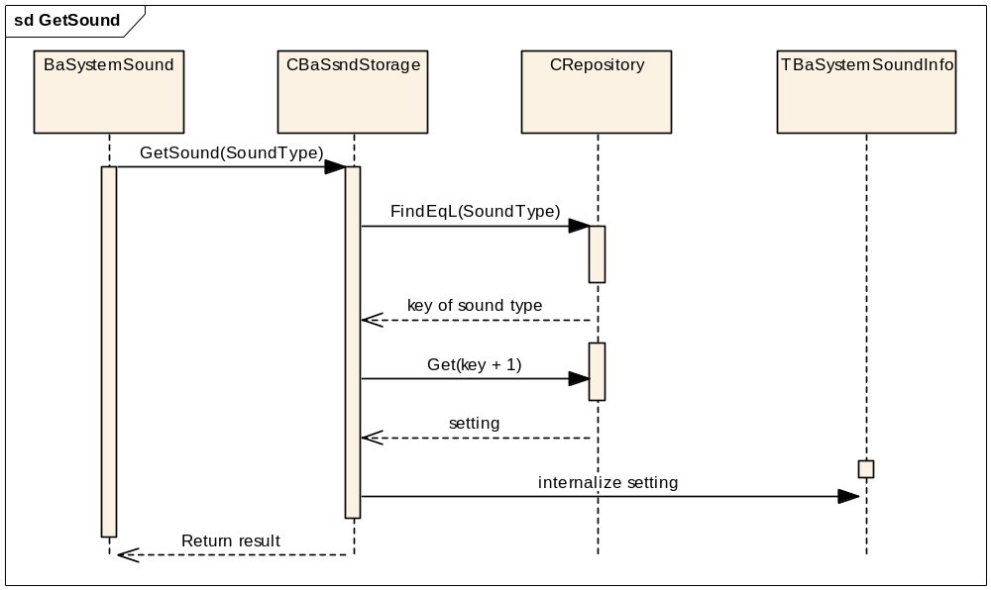
Figure 2 BaSystemSound::GetSound Interaction

SetSoundL Interaction
CBaSsndStore provides the SetSoundL method to be used by BaSystemSound::SetSoundL. In-source documentation of this method is shown below.
/** Write sound instance to persistent storage
@param aSoundInfo – the sound instance to save in storage
@leave – KErrNone if successful, else one of the system-wide error codes for other errors.
*/

The sequence diagram below shows how it works.
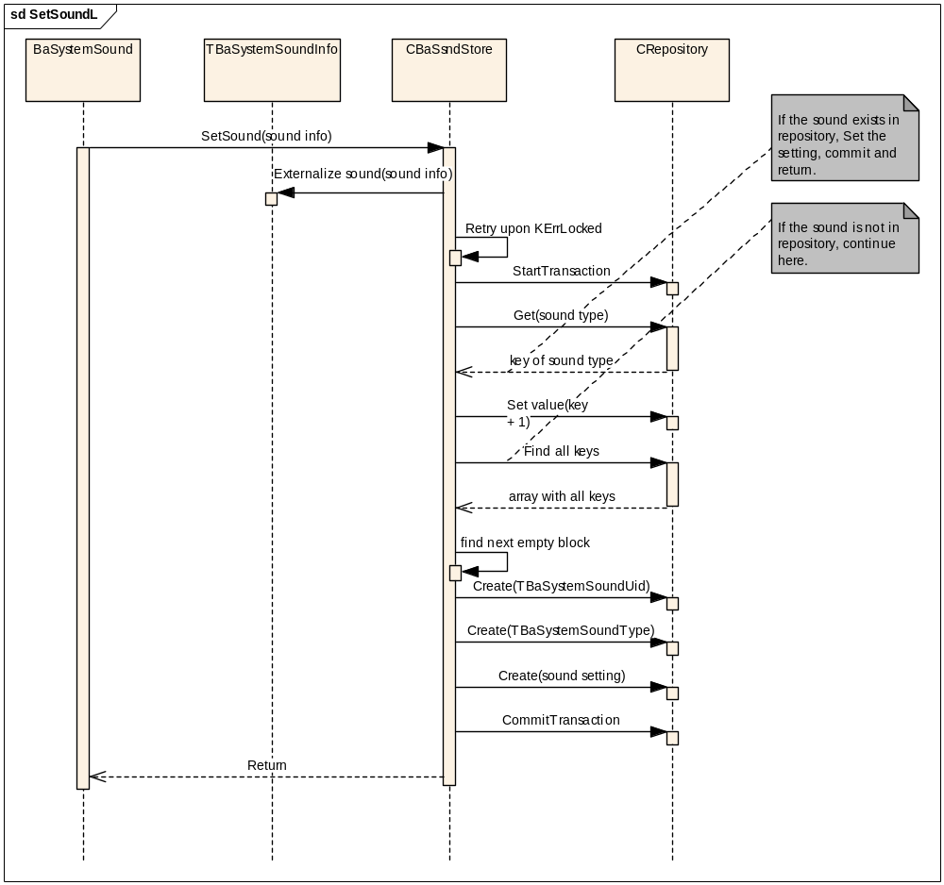
Figure 3 BaSystemSound::SetSoundL Interaction

CBaSystemSoundArray::RestoreL Interaction
CBaSsndStore provides the GetSoundCategory method to be used by CBaSystemSoundArray::RestoreL to fetch an entire sound category from repository. The in-source documentation of this method is shown below.
/** Retrieve all the instances of a sound category
@param – aSSUid identify the sound category to retrieve
@param – aArray on return contains all the sound instances of the given category.
@return – KErrNone if successful, KErrNotFound if category is not in store, or one of the
system-wide error codes for other errors.
*/

The sequence diagram below shows how it works.
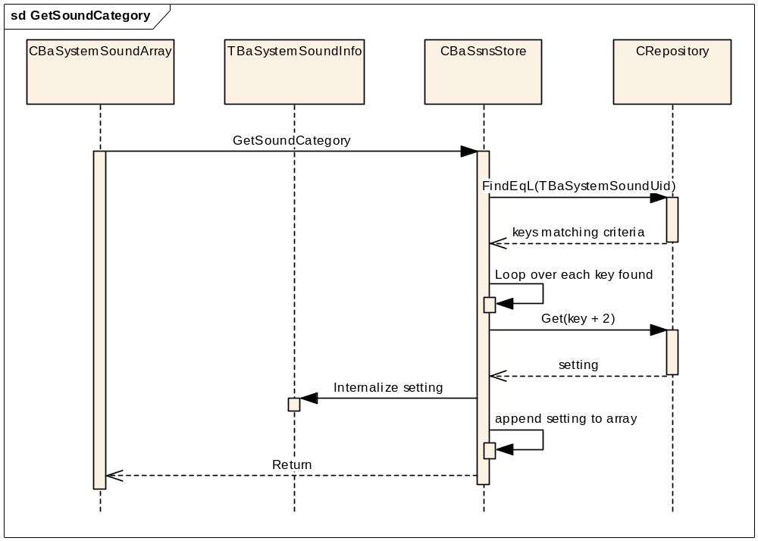
Figure 4 CBaSystemSoundArray::RestoreL Interaction

CentRep and Backup Registration Files
CentRep requires an initialization file which specifies:
- the access policies of the repository, and
- whether the settings need backup and restore.
The initialization file for System Sounds is shown in Appendix A . Comments are added in the appendix to high light the entries to instruct CentRep to:
- enforce write access requires WriteDeviceData capability, and
- backup and restore System Sound settings
Secure Backup and Restore Engine requires a registration file to be installed in Z:\private\100048AA. This registration file is shown in Appendix B .

Testing
This section describes the auto test cases to be added to BAFL System Sounds and manual test cases which need to be run prior to submitting the defect fix.

Performance Tests
No auto performance test cases need to be added. However manual performance test need to be run to measure boot time before and after fix. The GetSound API is called during critical static and critical dynamic states of the boot sequence. The fix must not severely degrade performance. During initial analysis phase, it was found that switching to CentRep slightly improved the performance of the GetSound API.

Component and Unit Tests
The following tests will be added to BAFL System Sound:
- A setcap test to verify that SetSoundL API will leave with KErrPermissionDenied if the test harness is missing WriteDeviceData capability.
- A backup and restore test to verify that sound settings are saved in backup and are restored.
- Test cases to verify SetSoundL behaves correctly under the race condition of two threads trying to create different/same sound type simultaneously.
- A test case to exercise CBaSystemSoundArray::RestoreL under OOM conditions. The current implementation has a test case which exercises SetSoundL under OOM. This test case indirectly tests CBaSystemSoundArray::RestoreL because SetSoundL uses CBaSystemSoundArray to load and write the sound to store. This is no longer the case in the new implementation.

Robustness Testing
This section describes robustness tests performed to check that BaSystemSound APIs behave as expected under various software and hardware failure modes such as CentRep server failure, server locked out and data corruptions.

CentRep server locked out
If backup is in progress, CentRep will reject set requests. If restore is in progress, CentRep will reject both set and get requests. Auto test cases are added to verify that KErrServerBusy is returned to clients if CentRep server is locked out by Backup and Restore.

CentRep server start fail
If CentRep fails to start due to OOM, data corruption etc., BaSystemSound will not be able to setup connection to CentRep. This failure mode is checked by manual one-time test on the emulator. The justification is that if CentRep can not start, the phone will crash. Thus no one will call the BaSystemSound APIs.

Data corruption at repository level
CentRep is very resilient against repository level corruption. If the file in the writable system drive is corrupted, CentRep will silently delete the corrupted file and use the one in ROM. Since auto test cases can not corrupt a ROM file, this failure mode is checked by manual one-time test.

Data corruption at settings level
Recall from section 3.1 that each sound occupies three CentRep settings. Robustness tests are performed on single failures only which are discussed below.
- The <TBaSystemSoundInfo> entry is corrupted or deleted. BaSystemSound can detect corruption in the TBaSystemSoundType, TSoundCategory, and the sound filename fields. Auto GetSound test cases are added to verify that KErrCorrupt is returned to clients when these three fields are corrupted. SetSoundL is not affected by this failure mode. The corruption will be overwritten by the new data. Corruption in other fields such as TTone, volume, priority etc. is not detectable and is only verified by manual one-time test.
- The <TBaSystemSoundType> entry is corrupted or deleted. This entry is used as hash key to locate the actual sound data. Neither GetSound nor SetSoundL can detect missing or corruption of this hash key (unless we are willing to sacrifice performance and use the other hash key to detect this corruption). GetSound will just return not found. But if the client uses CBaSystemSoundArray::RestoreL the sound instance will be listed. SetSoundL will append another instance of the sound at the end of the repository. These erroneous behaviours are checked with manual one-time test. The justification is that it is not worthwhile to test an error condition which is not detectable by the production code.
- The <TBaSystemSoundUid> entry is corrupted or deleted. This entry is used as hash key to speed up CBaSystemSoundArray::RestoreL. Corruption of this hash key does not affect GetSound and SetSoundL, but the list returned by CBaSystemSoundArray will be inconsistent with GetSound. Like the <TBaSystemSoundType> corruption, this failure mode is verified by manual one-time test only because the corruption is not detectable (unless we are willing to degrade performance).

Rogue entries in repository
If sound applications bypass SetSoundL and create their own entries in the System sound repository, the rogue entries may interfere with BaSystemSound APIs. The impact varies, depending on the contents of the entries and the bit pattern of the keys used:
- Key & 0x3 == 0. These entries have no impact on BaSystemSound APIs.
- Key & 0x3 == 1. CBaSystemSoundArray expects these entries to contain <TBaSystemSoundUid>. If the rogue entries’ values are not four bytes in length they will never match CBaSystemSoundArray’s query and have no impact on the API.
- Key & 0x3 == 2. GetSound and SetSoundL expect <TBaSystemSoundType> in these entries. If the rogue entries’ values are not eight byte in length, they will not interfere with the BaSystemSound APIs.
- Key & 0x3 == 3. If the rogue keys are contiguous with the rest of the sound data, i.e. follow the pattern 3, 7, 11, 15… with no gaps in between, they have no impact on SetSoundL. But if the key has a large value, e.g 0xFFFFFFFF, then SetSoundL will be tricked to wrap around and over write the first sound.
The last bullet is of great concern to BaSystemSound. An auto test case is added to check that SetSoundL can detect presence of gaps in the keys returned by CentRep.

Regress Tests
The existing test harnesses need the following changes:
- Add WriteDeviceData capability to their mmp files.
- Remove code which manipulate the old data file.

Further Information

References
No. | Document Reference | Version | Description
[R1] | //EPOC/master/common/generic/syslibs/bafl/docs/sys_sounds_func_spec.doc | 0.05 | Functional Spec of BAFL System Sounds API
[R2] | V:\Dev\TS\TS0017 Base Services\Component Documents\Bafl\SGL.TS0017.321 BAFL System Sounds Migration Guilde.doc | 1.0 | BAFL System Sounds Migration Guide
[R3] | //EPOC/master/common/generic/syslibs/bafl/docs/SGL.TS0017.650 Impact Analysis for DEF095280.doc | 1.0 | DEF095280 Impact Analysis

Open Issues
None.

People
Role | Person / People
Reviewers | Steven Mansfield
Contributors | Ext-Simon Chan
Location | V: \Dev\TS\TS0017 Base Services\RequirementsAnalysis\Defects\DEF095280 aka CR0881 System Sounds security vulnerability

Document History
Date | Version | Status | Author | Description
02-04-2007 | 1.0 | Issued | Stephen Mansfield | Document issued on submission.
02-03-2007 | 0.3 | For Review | Stephen Mansfield | Final review round
22-02-2007 | 0.2 | Draft | Simon Chan | Resolve issues raised by peer review
23-01-2007 | 0.1 | Draft | Simon Chan | First draft

- - CentRep initialization file for System Sound
cenrep
version 1

# required for backup and restore
[owner]
0x100048AA

# want backup and restore
[defaultMeta]
0x01000000

[platsec]
# Anyone can read. WDD required for write access
cap_rd=AlwaysPass cap_wr = WriteDeviceData

[main]
- - Backup registration file
<?xml version="1.0" standalone="yes"?>

<!-- Copyright (c) 2006, Symbian Software Ltd. All Rights Reserved -->

<backup_registration>
<proxy_data_manager SID="0x10202BE9" />
<restore requires_reboot="no" />
</backup_registration>

